Resources

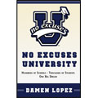  Book: No Excuses University — 100's of Schools, 1000's of Students, 1 Big Dream | 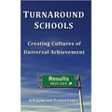  Book: TurnAround Schools — Creating Cultures of Universal Achievement | 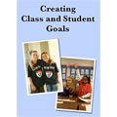  DVD: Creating Class and Student Goals
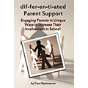  Book: Differentiated Parent Support | 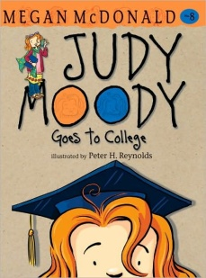  Judy Moody Goes to College  By: Peter Reynolds | 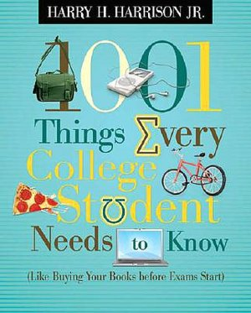  101 Things Every College Student Needs to Know  (use for adults not students)
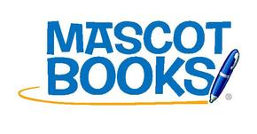  Mascot Books can be purchased from  www.mascotbooks.com or  Amazon.com | 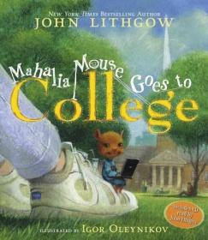  Mahalia Mouse goes to College  By John Lithgow | 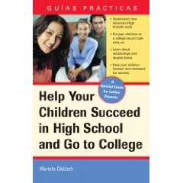  Help Your Children Succeed in High School and Go to College  By Mariela Dabbah

